4

Ocean Graham

Abstract

[Draw your reader in with an engaging abstract. It is typically a short summary of the document.   
When you’re ready to add your content, just click here and start typing.]

401IT – Operating Sysytems

[Assignment Title]



Table of Contents

Table of Figures 1

Heading 1 2

Heading 2 2

References 3

# Table of Figures

Figure 1 - Ubuntu ISO installation 2

Figure 2 - Ubuntu Virtual Machine creation 2

Figure 3 - Ubuntu Set up User and Password 3

Figure 4 - Ubuntu Define Resource allocation 3

Figure 5 – Ubuntu Assign Disk space and finish creation 3

Figure 6 - Ubuntu Startup screen 4

Figure 7 - Ubuntu preparing 4

Figure 8 - Ubuntu copying files 4

Figure 9 - Ubuntu login screen 5

Figure 10 - Windows 11 ISO Download 5

Figure 11 - Windows 11 Virtual Machine creation 6

Figure 12 - Windows 11 Set up User and Password 6

Figure 13 – Windows 11 Define Resource allocation 6

Figure 14 - Windows 11 Assign Disk space and finish creation 7

Figure 15 – Windows 11 Fail to boot error 7

Figure 16 - Windows 11 Boot manager 7

Figure 17 - Windows 11 Boot Manager Menu 8

Figure 18 - Windows 11 Optical Disk Selection 8

Figure 19 – Windows 11 Installation 8

Figure 20 – Windows 11 Successful Installation 9

Figure 21 - Server 2022 ISO download 9

Figure 22 - Server 2022 Virtual Machine creation 10

Figure 23 - Server 2022 Set up User and Password 10

Figure 24 – Server 2022 Define Resource allocation 10

Figure 25 – Server 2022 Assign Disk space and finish creation 11

Figure 26 - Server 2022 installation 11

Figure 27 – Server 2022 Successful Installation 11

Figure 28 - Server 2022 GUI Setup 12

Figure 29 - Server 2022 GUI Setup Desktop Experience selection 12

Figure 30 - Server 2022 Installation 2 12

Figure 31 - Server 2022 GUI Post download setup screen 13

Figure 32 - Server 2022 Home screen 13

401IT – Operating Systems

# Introduction

This coursework will demonstrate a high degree of understanding of operating systems via a collection of exercises conducted for XYZ Tech solutions. This coursework is designed as a portfolio which is divided into 3 sections each displaying understanding of different aspects within different operating systems (Ubuntu Linux, Windows 11 and Windows Server 2022).

# Installation of different operating systems

VirtualBox, was utilised to simulate a real-world IT infrastructure as expected of XYZ Tech Solutions. VirtualBox was used to create 3 virtual Operation Systems, these being Linux Ubuntu, Windows 11 and Windows Server 2022. This section will display the installation process of these 3 Operating systems via the virtual machines.

## Linux Ubuntu

Figure 1 - Ubuntu ISO installation

Figure 2 - Ubuntu Virtual Machine creation

Figure 3 - Ubuntu Set up User and Password

Figure 4 - Ubuntu Define Resource allocation

Figure 5 – Ubuntu Assign Disk space and finish creation

Figure 6 - Ubuntu Startup screen

Figure 7 - Ubuntu preparing

Figure 8 - Ubuntu copying files

Ubuntu restarts after successful installation and results in this login screen. This concludes the installation of Linux.

Figure 9 - Ubuntu login screen

## Windows 11

Figure 10 - Windows 11 ISO Download

Figure 11 - Windows 11 Virtual Machine creation

Figure 12 - Windows 11 Set up User and Password

Figure 13 – Windows 11 Define Resource allocation

Figure 14 - Windows 11 Assign Disk space and finish creation

Figure 15 – Windows 11 Fail to boot error

Going into the boot manager and selecting the CD-ROM option can get into the system. However, on shutdown of the system, this boot error repeats.

Figure 16 - Windows 11 Boot manager

Figure 17 - Windows 11 Boot Manager Menu

Figure 18 - Windows 11 Optical Disk Selection

Attempt to attach Windows 11 ISO to optical drive as well as remove unattended files, to resolve issue.

An alternative version of windows was installed with different settings (double the Hard Disk Memory of the original) which resolved the originals boot problems.

**Figure 19 – Windows 11 Installation**

Figure 20 – Windows 11 Successful Installation

## Windows Server 2022

Figure 21 - Server 2022 ISO download

Figure 22 - Server 2022 Virtual Machine creation

Figure 23 - Server 2022 Set up User and Password

Figure 24 – Server 2022 Define Resource allocation

Figure 25 – Server 2022 Assign Disk space and finish creation

Figure 26 - Server 2022 installation

Figure 27 – Server 2022 Successful Installation

A second version of Server 2022 was installed as the original lacked a GUI.

Figure 28 - Server 2022 GUI Setup

Figure 29 - Server 2022 GUI Setup Desktop Experience selection

Figure 30 - Server 2022 Installation 2

Figure 31 - Server 2022 GUI Post download setup screen

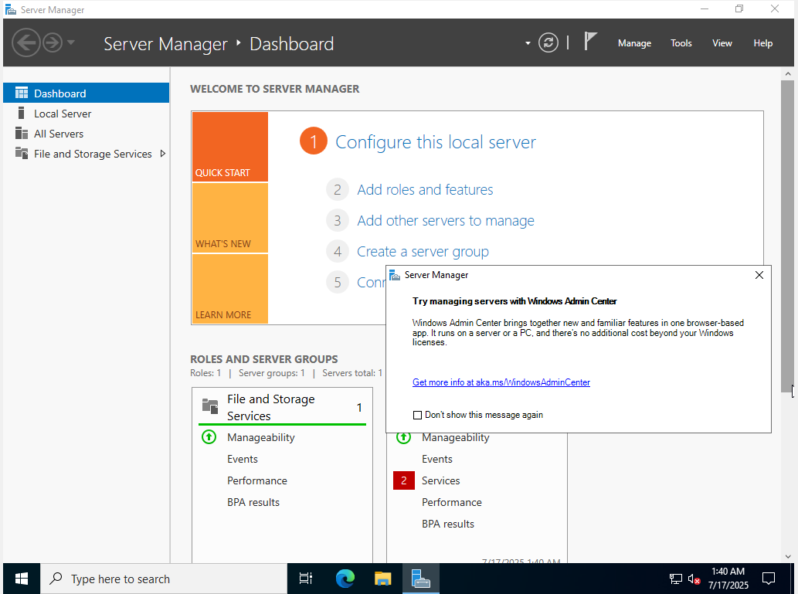

Figure 32 - Server 2022 Home screen

Successful Installation of Windows Server 2022

# usage of different operating systems

## User Account Management

User account management is the effective management of users and their accounts, this controls access to resources such as devices, files and applications. (Soni, 2021) This allows admins to allow or restrict access based on an organisational role the user performs. User management is essential in ensuring security and safety within an organisation, meaning users have access to only items they have clearance for based on their hierarchy. (Mohite, 2024)

Multiple different accounts of different authority across the different systems have been created, these being based on roles and where they would work within the XYZ Tech Solutions Organisation.

### Linux Ubuntu

GUI Creation - Developer:

Figure 33 - Ubuntu GUI User creation

Figure 34 - Ubuntu GUI User creation password selection

Figure 35 - Ubuntu GUI User created

CLI Creation – Admin, Intern:

Figure 36 - Ubuntu CLI User creation - Intern

Figure 37 - Ubuntu CLI User creation - Admin

(The Admin group is the predecessor to Sudo (Prior to 12.04 LTS) this being replaced by Sudo in later versions)

Figure 38 - Ubuntu give Admin user Sudo/Admin privileges

Figure 39 - Ubuntu created Users

### Windows 11

GUI Creation – Admin, Intern:

Figure 40 - Windows 11 GUI Account creation setting

Figure 41 - Windows 11 GUI User creation – Intern

Figure 42 - Windows 11 GUI User creation - Admin

Give Admin higher clearance with the Administrator Account type.

Figure 43 - Windows 11 GUI User creation - Account types

Figure 44 - Windows 11 GUI Users created

CLI Creation – Developer, Human resources:

Figure 45 - Windows 11 CLI User creation

Figure 46 - Windows 11 All Users created

### Windows Server 2022

GUI Creation – Server Manager:

Figure 47 - Server 2022 GUI User created - Server Manager

CLI Creation – Admin:

Figure 48 - Server 2022 CLI User created – Admin

Group Creation

“Groups are a collection of users who share the same permissions or privileges” (Solanki, 2024). Groups make it easier for an organisation to assign privileges on a larger scale. Group creation was done via Windows Server 2022.

Figure 49 - Server 2022 Group creation

Figure 50 - Server 2022 Groups created

Figure 51 - Server 2022 Group Privilege assignment - Server Manager

Figure 52 - Server 2022 Group Privilege assignment - Admin

## Linux and Windows Scripting

## Command Line Interface Usage

# managing vulnerabilities

## Operating System Security risks and vulnerabilities

## Technologies and management Strategies for risk mitigation

# COnclusion

# References